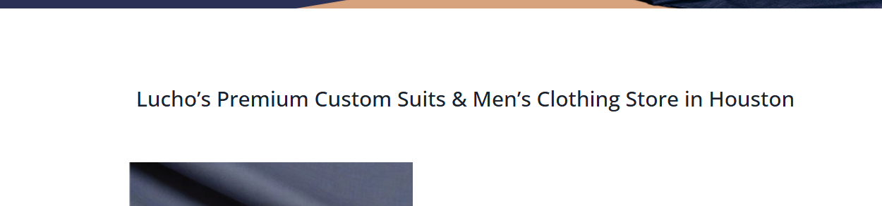

Heading:

Lucho custom suits for men in Houston, Tx H1

Established 1961

CTA: **Book An Appointment**

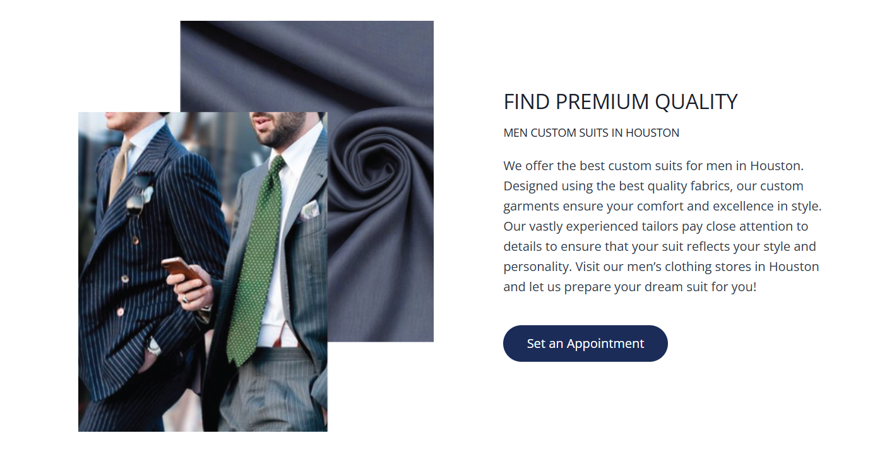

**Heading 1 h2 : call secondary keyword**

**Heading 2 h3 call secondary keyword**

Need to expand the content a bit.

CTA: Design Your Perfect Suit

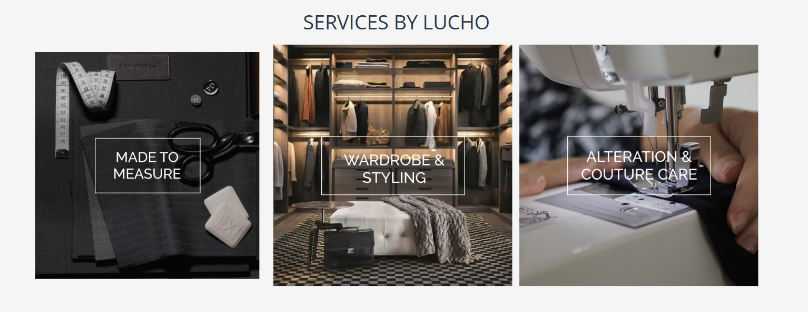

Change the heading

Custom Suit and Styling Services by Lucho

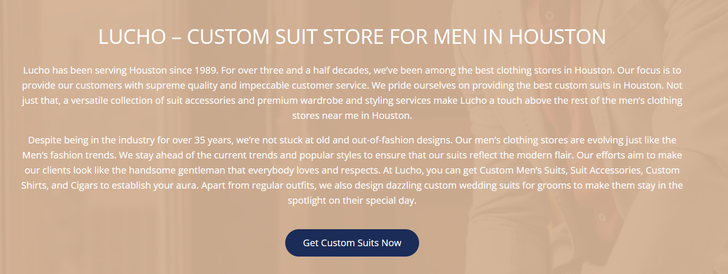

Add one more paragraph

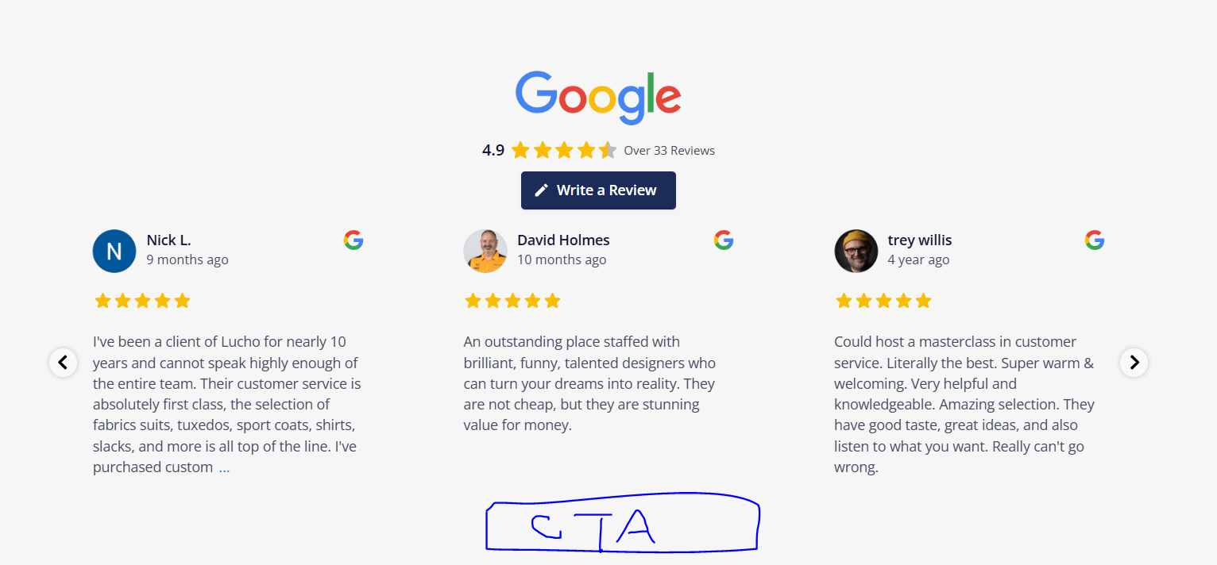

CTA: Explore Custom Made

Link: <https://lucho.com/for-men/>

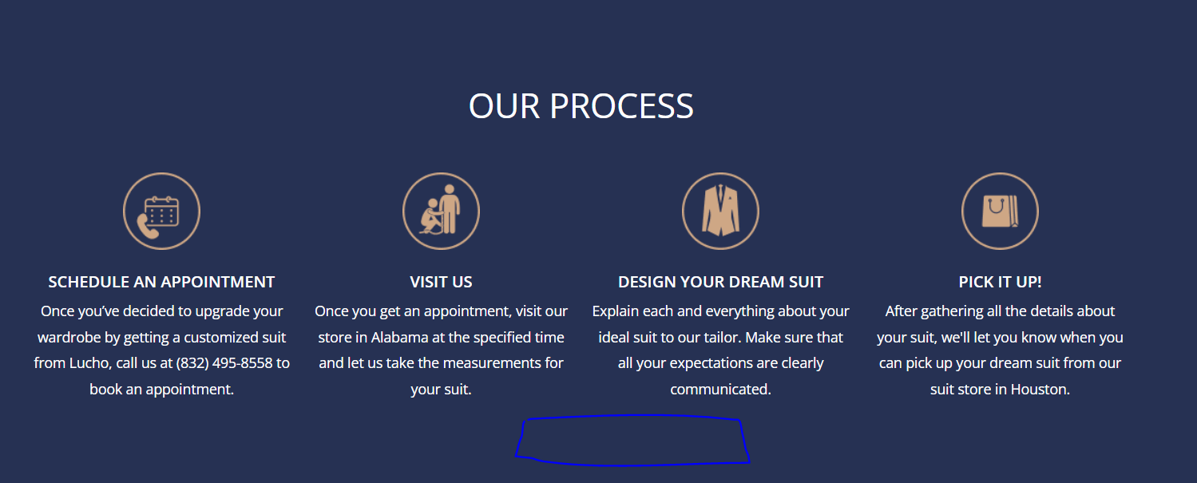

Change the heading:

Custom Tailoring: Our Step-by-Step Process

CTA: **Schedule a Fitting**

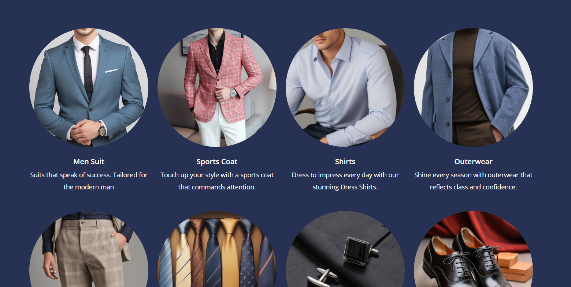

**Heading:**

**Custom Suits and Accessories: Redefine Your Style with Tailored Perfection**

**Here add some content**

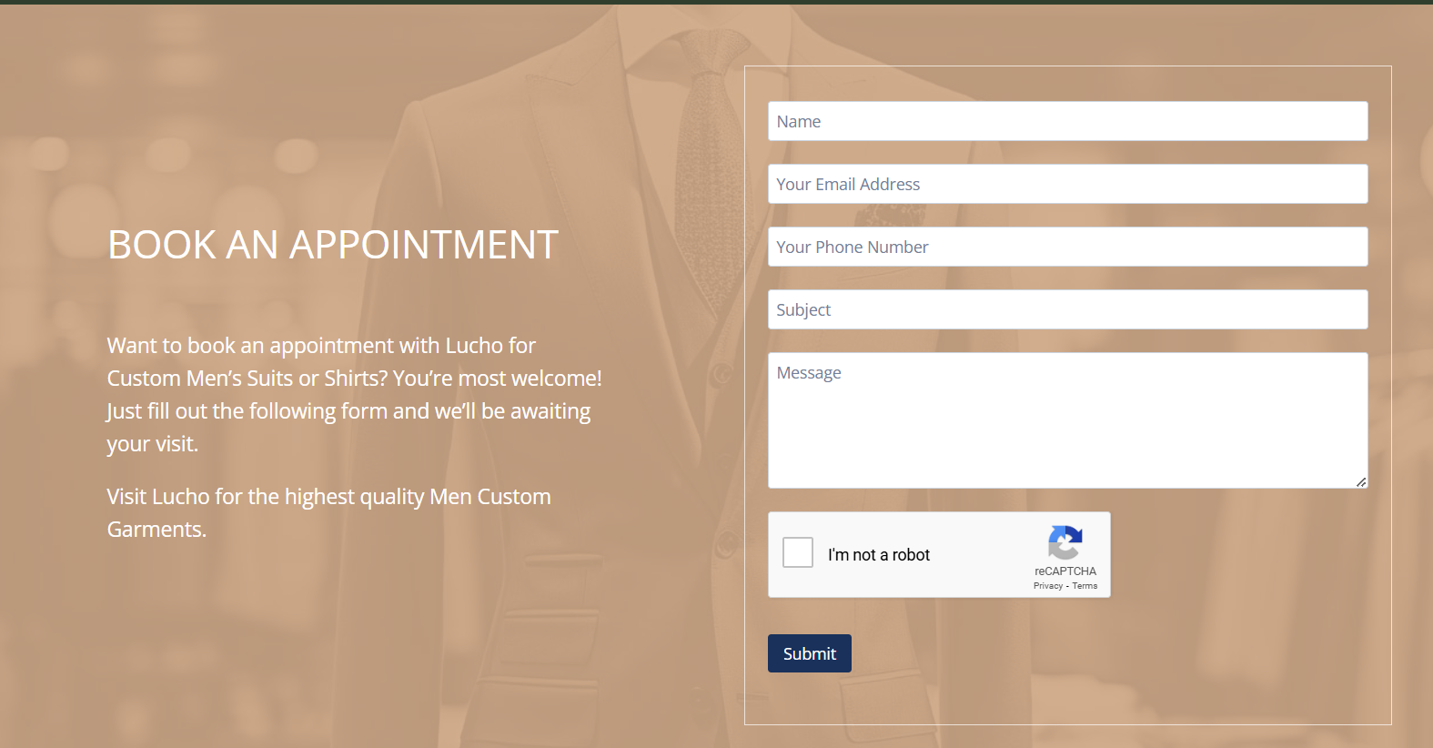

**Add some text more**

**FAqs:**

**6 more**